|  |  |
| --- | --- |
| BAAL TEA SIG  **Testing Evaluation Assessment Special Interest Group** | 2018 Annual General Meeting  Nottingham Trent University  13 April 2018 |

**Minutes**

1. **Checking attendance and quorum for meeting:** Quorum of 18 people present.
2. **Confirming minutes of previous AGM:** Minutes from last AGM confirmed.
3. **Convenor’s report**
   * Coordinating Committee introduced

|  |  |
| --- | --- |
| Convenor | Elaine Boyd |
| Treasurer | Nahal Khabbazbashi |
| Meeting Coordinator | Judith Fairbairn |
| Communication Officer | Sathena Chan |
| Ordinary Member | Susan Sheehan |
| Ordinary Member | Glyn Jones |

**SIG CONFERENCE 2017**

* A TEA SIG conference was held on 31 March at the University of Northampton. The conference was jointly hosted by the TEA SIG and the university. The theme was ***Innovations in English for Academic Purposes (EAP) assessment***.
* The conference was very well attended with 45 registered participants. Following the practice of past TEA SIG conferences, all presentations are made in plenary session. A call for papers was put out in September 2016, and all proposals were reviewed by 2 reviewers. The program consisted of 4 invited speakers, 5 presentations, 5 poster presentations and a panel discussion. The presentations have been made publicly available on the SIG website. <http://www.beds.ac.uk/baalteasig/events/2017>

**SIG STRAND AT MAIN BAAL CONFERENCE**

* A TEA SIG strand was included in the BAAL 2017 conference at Leeds University. It was not very well attended with only a few people in the audience. There were three presentations but one person dropped out at the last minute. It overlapped with similar SIGs.

**SIG STRAND AT 2018 MAIN BAAL CONFERENCE**

* It was decided not to have a separate TEASIG strand at the main BAAL conference.

**2019 SIG Conference**

* The venue for the conference has been suggested as IoE, UCL London.
* The Coordinating Committee will begin work on a theme with the local organizer and a call for papers will be issued in July 2018.

1. **Communication Officer’s report**
   * BAAL TEA SIG Membership and Website
     + 148 members in total
     + 64 BAAL members
     + 80 non-BAAL members
     + 87 institutions across 16 countries
     + Website: <http://www.beds.ac.uk/baalteasig>
2. **Treasurer’s report**

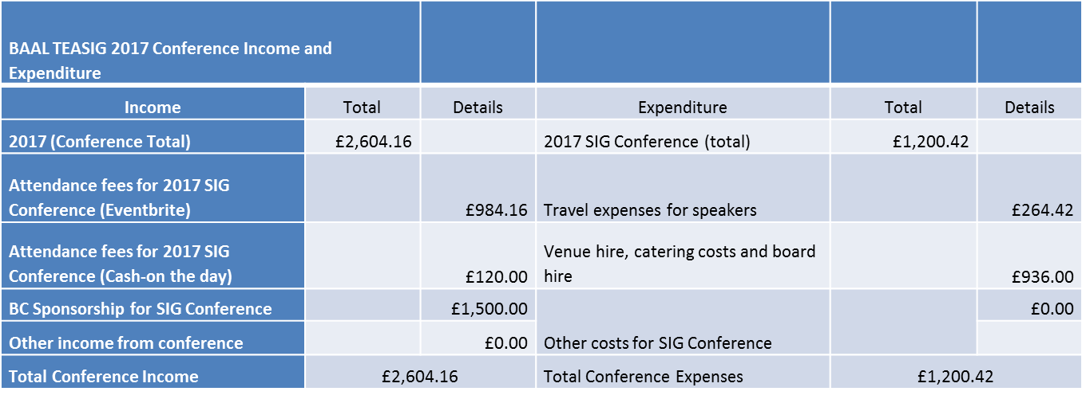

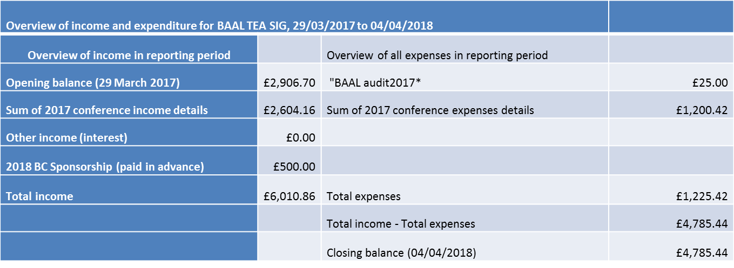

1. **Election of new committee member**

|  |  |  |
| --- | --- | --- |
| **Position** | **New Term** | **Nominees** |
| **Meeting coordinator:** | 2018-2020 | Mark Griffiths  Qian Zang |
| **Treasurer:** | 2018-2020 | Jing Xu |
| **Ordinary member:** | 2018-2020 | Gemma Bellhouse |

* + Meeting coordinator post was a tie with 9 votes for Mark and 9 for Qian. The meeting ended with an action point for the Convenor (Elaine Boyd) to check the constitution on what to do in the case of a tie.

1. AOB - none